TCP Server with Custom Protocol:

Implement a TCP server that:

Binds to port 2020.

Listens for incoming connections.

Implements a simple custom protocol where:

The first byte of the message indicates the type of operation (e.g., 1 for echo, 2 for reverse).

For operation type 1, the server echoes the message back.

For operation type 2, the server sends back the reversed message.

Closes the connection and terminates.

Server Part:

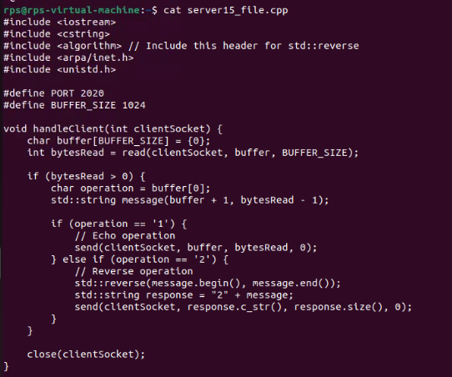

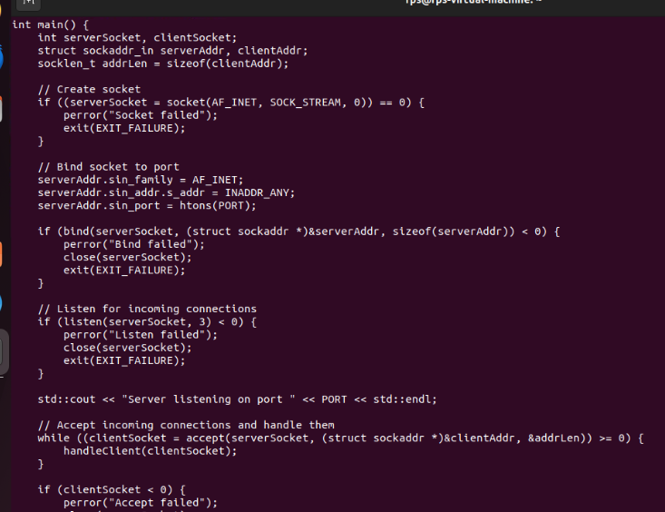

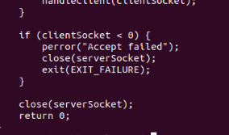

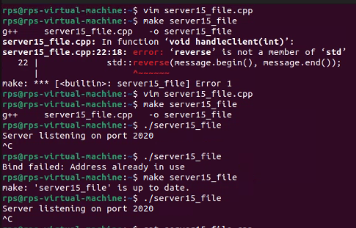

Client Part:

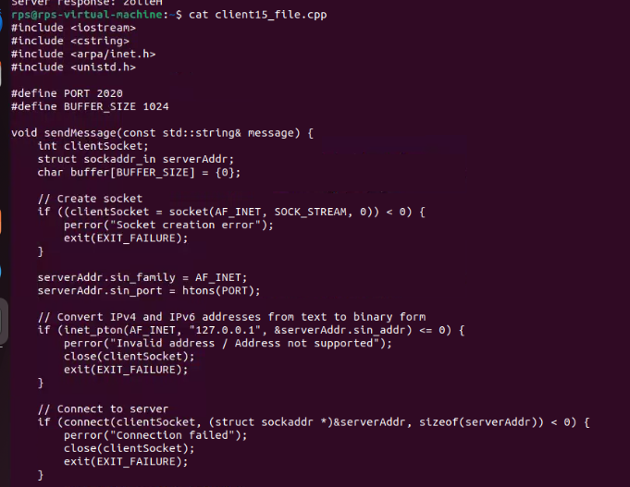

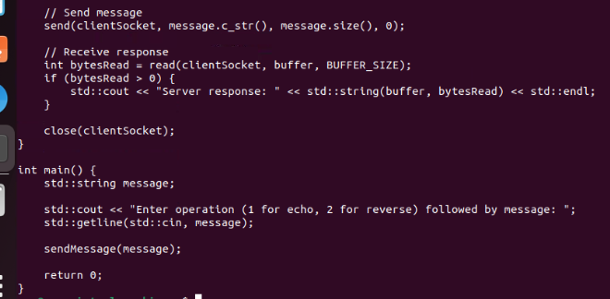

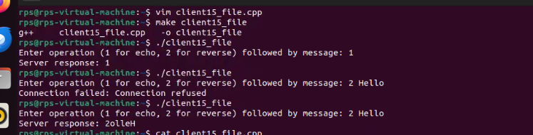

Problem 5: Secure Communication with Signal Handling

Design a C++ application that establishes a secure communication channel between a client and a server using SSL/TLS over sockets. Implement signal handling to allow both the client and the server to clean up and close the secure connection gracefully upon receiving a termination signal.

Server Part:

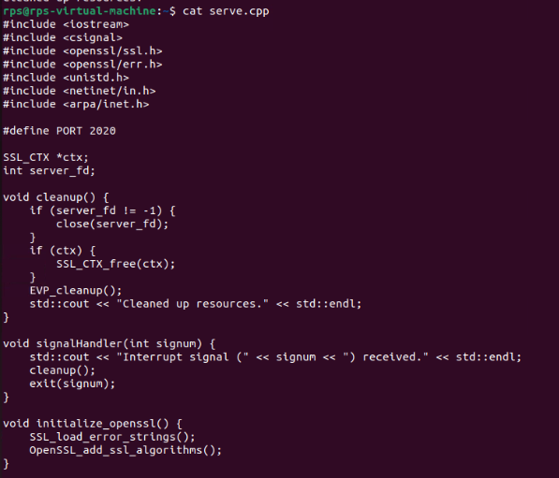

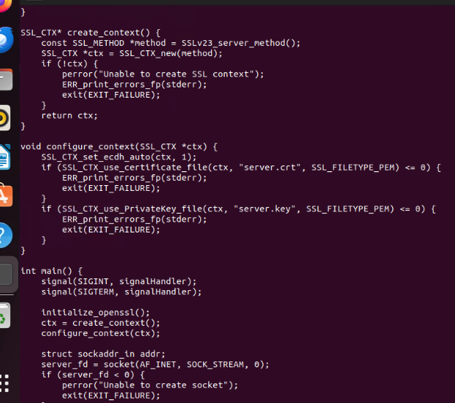

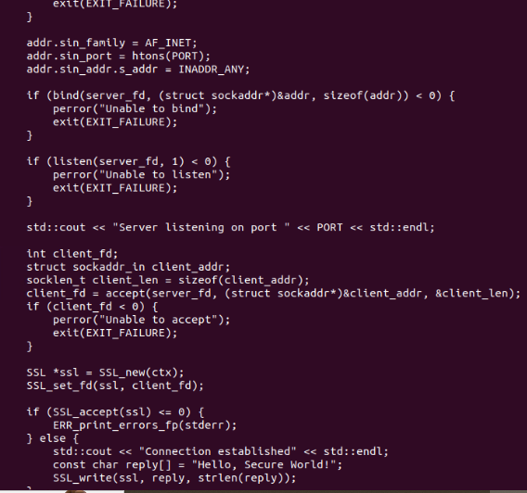

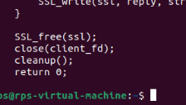

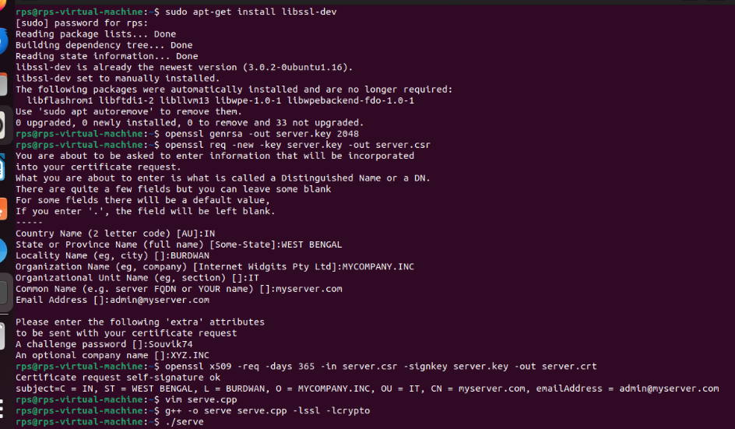

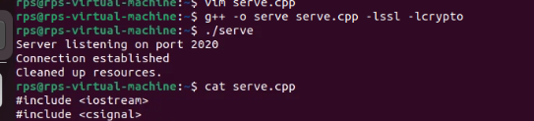

**Client Part:**

